

Generic Payment Service
(GPS)

System Architecture Specification

Version 1.2
2013-11-08



Revision History
Version | Date | Author | Description
0.4 | 2013-10-02 | Chahid Benamar  Yves Robichaud  Sylvain Veillette | First draft version to review with the Bell team members.
1.0 | 2013-10-04 | Sylvain Veillette | Version for approval after minor adjustments from the review with the Bell team members.
1.1 | 2013-10-22 | Sylvain Veillette | Section 2.2.7: updated diagram to show number of destinations as per CR014  Section 2.2.8: updated list of BSSs as per CR014.  Section 2.4.1 : updated diagram
1.2 | 2013-11-08 |  | Section 2.2.1 : diagram updated to show final target for load balancing to DTS-ESB.  Section 2.2.2 Flow description updated to describe final target for load balancing to DTS-ESB.
Table of Contents
1. Introduction 5
1.1 Document Objective 5
1.2 Document Scope 5
2. System Architecture Specification 6
2.1 Conceptual View Model 7
2.1.1 Conceptual model Diagram 7
2.1.2 Conceptual model description 8
2.1.2.1 GPS Overview 8
2.1.2.2 GPS Online Interface 8
2.1.2.3 Enterprise Service Bus (DTS-ESB) component 8
2.1.2.4 GPS Batch Functions 8
2.1.2.5 GPS Parameters Data Store 8
2.1.2.6 GPS Transaction Data Store 9
2.1.2.7 GPS Transaction Data Store (Replicated) 9
2.1.2.8 Audit logs 9
2.1.2.9 EDX Gateways 9
2.1.2.10 Data Tokenization System (DTS) and RSA Tokenization System (RTS) 9
2.1.2.11 Business Support Systems (BSS) 10
2.1.2.12 Open Database Connectivity (ODBC) 10
2.1.2.13 Chargeback Reports Recipients 10
2.1.2.14 Moneris 10
2.1.2.15 AMEX (American Express) 10
2.1.2.16 Key management and dissemination 10
2.2 Process View Model 11
2.2.1 Online Credit Card Transaction Request Process Diagram 11
2.2.2 Online Credit Card Transaction Request Process Description 11
2.2.3 Batch Credit Card Transaction Request Process Diagram 13
2.2.4 Batch Credit Card Transaction Request Process Description 13
2.2.5 Chargeback Report Files Generation and Distribution Process Diagram 15
2.2.6 Chargeback Report Files Generation and Distribution Process Description 15
2.2.7 Daily Report Files Distribution Process Diagram 16
2.2.8 Daily Report Files Distribution Process Description 17
2.3 Development View Model 18
2.3.1 Components Model Diagram 18
2.3.2 Components Model Description 18
2.3.2.1 GPS Services 18
2.3.2.1.1 GPS Online Service 18
2.3.2.1.2 GPS Batch Service 19
2.3.2.2 GPS Components 19
2.3.2.2.1 GPS Core 19
2.3.2.2.1.1 Logical Layers 19
2.3.2.2.1.2 Frameworks and Third Party Libraries 20
2.3.2.2.2 GPS Core Business Functions 20
2.3.2.3 GPS Batch 21
2.3.2.4 GPS Batch Third Party Frameworks 21
2.3.2.4.1 Spring Batch 21
2.3.2.4.2 Spring Integration: 21
2.3.2.4.3 GPS Batch Functions 22
2.3.2.5 GPS Online 22
2.3.2.6 Monitoring and Reporting 23
2.3.2.7 DTS-ESB 23
2.4 Physical View Model 24
2.4.1 Production Environment Diagram 25
2.4.2 Production Server Components 26
3. Glossary 28

Introduction

Document Objective
To provide Bell Canada and CGI project team members with details on the System Architecture Specification to support the GPS System Design Specification.

Document Scope
The present document describes from an architectural point of view the Generic Payment Service system (GPS) at its actual state of implementation.

System Architecture Specification
The complexity of a system architecture should not be forced on a single diagram or description. This makes it easier to understand the overall solution. Furthermore, different stakeholders can have their concerns addressed by different views which help communication of the architectural solutions. The following diagram illustrates four views and, for each one, identifies a typical stakeholder and the corresponding area of concern. The diagram also shows the System Design Specification at the center of those four views. The System Specification can also be considered a fifth view.

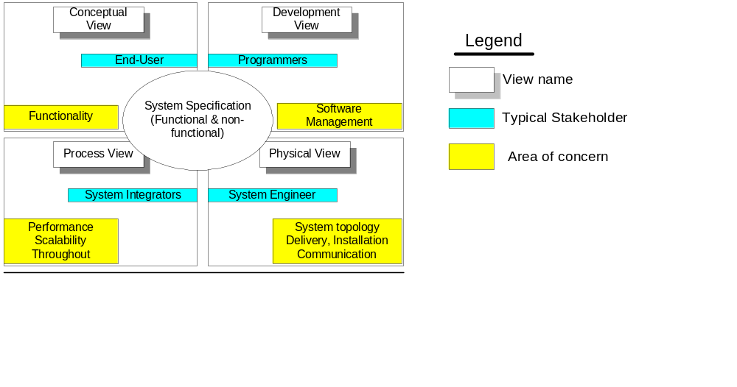

Conceptual View Model
The conceptual model exposes the interactions of the end-user with the system. Since the Generic Payment Service system (GPS) is more specifically a framework integrating different systems, this section is used to present a summary of the interactions involved in the different credit card transaction functions addressed by the solution.

Conceptual model Diagram

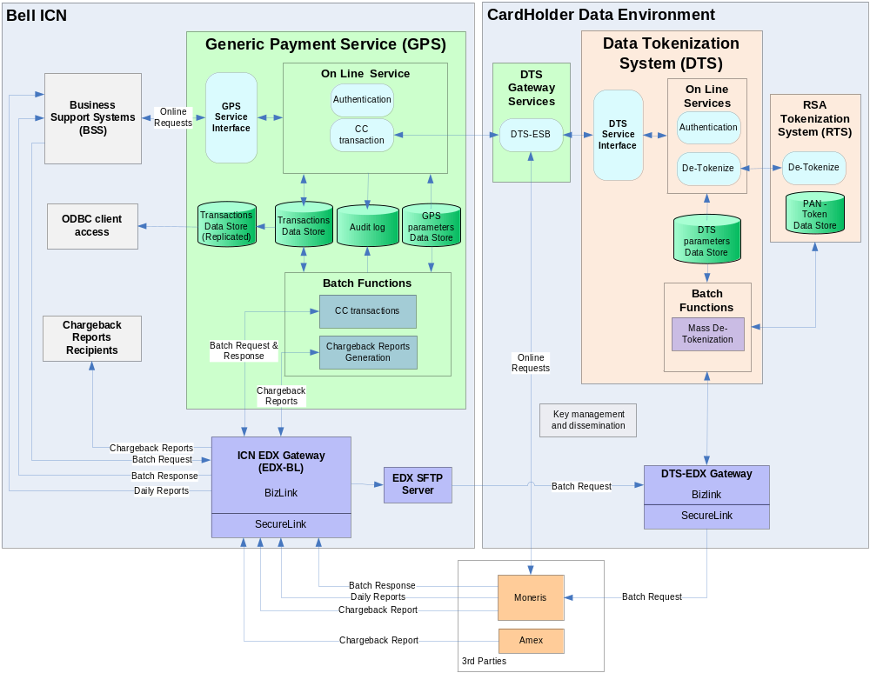

Conceptual model description

GPS Overview
The GPS system main role is to provide, through online and batch interfaces, an abstraction layer between Bell Business Support Systems (BSS) and the credit card payment processor to be integrated in the present project, which is Moneris. Its core functions are to transform and enrich credit card related transaction messages exchanged between the BSSs and Moneris.
GPS integrates with the existing Data Tokenization System to leverage Bell Payment Card Industry – Data Security Standards (PCI-DSS) compliant processes for interactions with Moneris requiring the communication of credit card numbers (aka Primary Account Number or PAN)
GPS also leverages the Bell EDX gateways established file transfer system for efficient and secure file exchanges across integrated systems.

GPS Online Interface
GPS exposes an online service through a Web Service interface.
The online requests are first challenged by an authentication mechanism before being processed and forward to the DTS ESB system component.

Enterprise Service Bus (DTS-ESB) component
The DTS-ESB is an existing DTS system component acting as a gateway for DTS service functions required for online interactions with external 3rd parties. For the avalanche project, it is leveraged to include an interface to specifically process online requests coming from GPS requiring a de-tokenisation step before interacting with Moneris.

GPS Batch Functions
The GPS batch functions or services are exposed trough a file transfer mechanism and triggered on the presence of preconfigured feeds, either from a BSSs or from an external partner (Moneris or Amex).
Input files processed by GPS are the following:
- Batch credit card transaction requests from a BSS
- Batch credit card transaction response from Moneris
- Chargeback report files from Moneris and Amex

Although not requiring any GPS processing, the distribution of report files generated by Moneris is considered as a GPS batch service. These file transfers are however solely performed by the EDX-BL gateway component located in the ICN.

GPS Parameters Data Store
The processing, transformation and enrichment of request and response messages (both on line and batch messages) are based on rules and parameters held in the GPS Data Store. For example, for GPS batch function rules and parameters allow the determination of the response file structure to be generated for a specific BSS. Routing information for report distribution and Merchant Identifiers mapping are other examples of the GPS parameters kept in the data store.

GPS Transaction Data Store
The GPS transaction data store is used for the persistence of credit card requests and responses information to support:
- Enrichment of exchanged messages, both for online and batch
- Generation of Bell internal chargeback report files
- Provide credit card transactions information to support investigation and reconciliation activities performed by Bell operation groups.

GPS Transaction Data Store (Replicated)
The GPS transaction replicated data store is an active copy of the transaction data store accessible in read access mode only for the Bell operation groups as well as the GPS application support group activities.
Queries to the GPS data store are only run against this copy not impact the GPS system performance.

Audit logs
Information on GPS processing to allow complete reconstruction of the end-to-end transmission and processing of any credit card transaction and also to support required tracking, troubleshooting and investigation activities. The logs are stored at the local file system level.

EDX Gateways
The EDX-BL and DTS-EDX gateways are used in conjunction for end to end batch file transfers between integrated systems.
EDX-BL is providing the file transfer transport for all files not containing any credit card numbers (PANs).
As only the CDE environment can host PANs, batch request files containing tokens to be substituted by corresponding PANs transit to the DTS-EDX gateway to reach DTS-RTS for the de-tokenization process before being forwarded to Moneris.
File exchange between EDX-BL and DTS-EDX must go through the dedicated EDX-SFTP server hosted on the ICN DTS Gateway in order to maintain PCI-DSS compliancy.
All file transfers with the Internet for any of the EDX gateways must transit through its associated SecureLink proxy.

Data Tokenization System (DTS) and RSA Tokenization System (RTS)
These are CDE existing components solely integrated to GPS to leverage online and batch de-tokenization functions.

Business Support Systems (BSS)
BSSs integrated to GPS use online and/or batch service as follows:
- Online request service only:
  - CSM NM1/SV
  - Onebill
  - Virgin Prepaid
- Batch request service only:
  - Bell West Singl.eView
  - EDIRIS
  - MaxPaging
- Online and batch request service:
- Fund$In

Open Database Connectivity (ODBC)
ODBC access to the replicated GPS transaction database is used by some of the Bell operation groups involved in credit card transaction investigation and reconciliation.

Chargeback Reports Recipients
These are in fact destination folders to receive chargeback reports processed by GPS.

Moneris
Moneris is the processor and acquirer for American Express, MasterCard and Visa credit card transactions. Moneris also provide reconciliation and chargeback reports.

AMEX (American Express)
Amex is the card issuer that provides Chargeback reports exclusively for American Express credit card transactions.

Key management and dissemination
Existing set of tools and processes hosted in the CDE to securely generate and disseminate keys with external partners, like SSH key for SFTP site access required for secure file transfer.
Note that the CDE key management tools and processes do not cover the following which is under the GPS and BSSs support teams responsibility:
- GPS Client certificate required to authenticate to DTS-ESB
- BSSs Client certificate required to authenticate to GPS

Process View Model
The following sections give an overview of the 4 GPS processes:
- Online credit card transaction request
- Batch credit card transaction request
- Chargeback report files generation and distribution
- Daily report files distribution

Online Credit Card Transaction Request Process Diagram

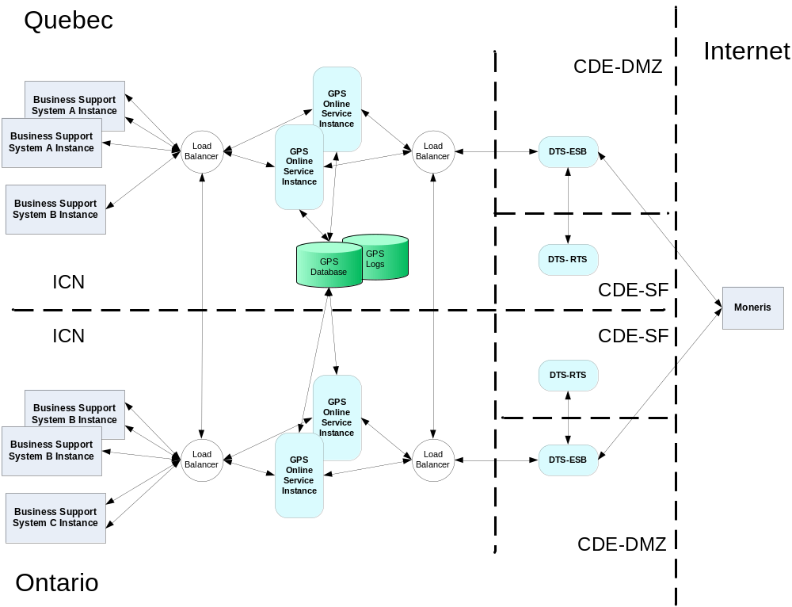

Online Credit Card Transaction Request Process Description
Online credit card transaction requests originate:
- Concurrently from any of the below business support system (BSS), 24 hours a day, 7 days a week:
  - Virgin Prepaid
  - Fund$In
  - OneBill
  - CSM NM1/SV
- Up to 15 transaction requests per second for all the BSSs
- From any BSS system instance across the ICN, for example from the Wynford or Dorval datacenter
- Simultaneously from any of the BSS instance
Online credit card transaction requests must receive a reply within 2 seconds, no matter what the processing status is.

Process flow description:
- The BSS invokes the GPS synchronous Web service interface
- The global load balancer intercepts the request and direct it on a round robin algorithm to ensure even load distribution at all times across all GPS online instances
- On received request, GPS:
  - Transforms and enriches the request
  - Synchronously reads and writes transaction data to the GPS database
  - Asynchronously writes internal processing information to the GPS database log tables
- After transaction transformation and enrichment, GPS invokes the synchronous DTS-ESB web service interface
- The local load balancer intercepts the request and directs it on a round robin algorithm to ensure even load distribution at all times across all DTS-ESB online instances
- For any request containing a token, DTS-ESB invokes the DTS synchronous Web service interface to get the corresponding PAN
- After PAN substitution, DTS-ESB invokes the Moneris synchronous HTTPS XML interface.
- On reply from Moneris, or after a timeout delay is reached, ESB returns the response message to GPS
- On reply from DTS-ESB, or after a timeout delay is reached:
  - GPS synchronously writes transaction data to the GPS database
  - GPS asynchronously writes internal processing information to the GPS database log tables
- After DTS-ESB response transformation and enrichment, or timeout, GPS returns the response message to the BSS

Batch Credit Card Transaction Request Process Diagram
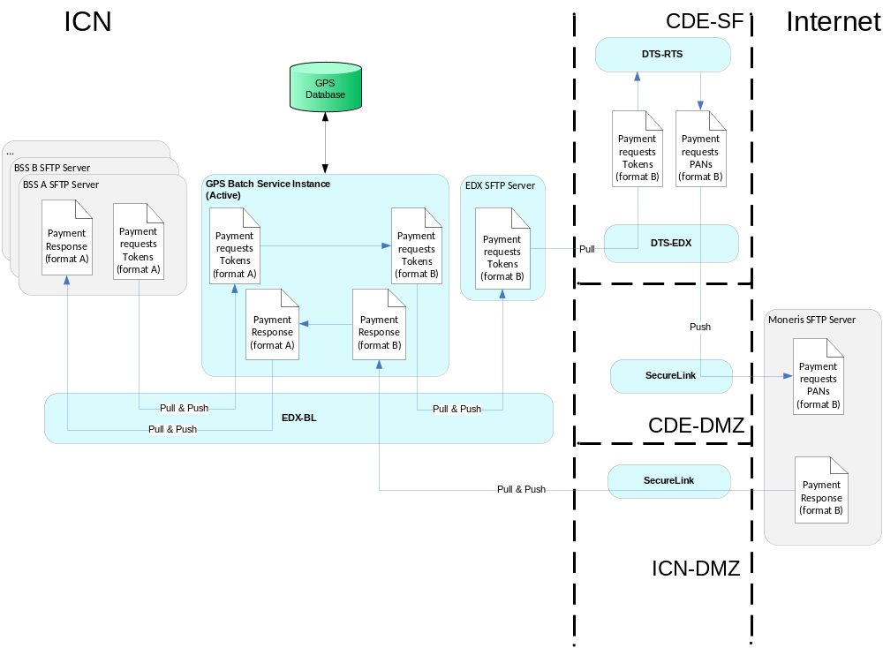

Batch Credit Card Transaction Request Process Description
Batch credit card transaction request files originate from any business support system (BSS) hosted on the ICN, as per the below schedule:
- EDIRIS
  - PACBEL file, up to 60K purchase records, sent around 6h30AM, Monday to Friday
  - PACBMC file, up to 120K purchase records, sent around 9h00AM, 7 days a week
  - PCDMAX file, about 200 purchase records, sent around 9h00AM, Monday to Friday
  - PCDMMC file, about 200 purchase records, sent around 9h00AM, Monday to Friday
  - PCDMVI file, about 200 purchase records, sent around 9h00AM, Monday to Friday
- MaxPaging
  - One file, about 1400 purchase records on the 10th of each month
- Fund$In
  - One batch file per day, sent around 6:30AM, Monday to Friday except holidays.
  - 35K to 70K purchase requests per month
- Bell West Singl.eView
  - Around 1000 purchase requests monthly, divided in 2 runs per month (sound the 15th and 30th of each month)

Batch credit card transaction request files issued must be processed and forwarded to Moneris within 1 hour.
Expected elapse time from the time Moneris receives the batch credit card transaction request file and issues a response file is maximum 3 hours.
Batch credit card transaction response files issued from Moneris must be processed and forwarded to the BSS within 1 hour.

Process flow description:
- The BSS generates a credit card transaction request file and make it available in a predetermined SFTP folder
- EDX-BL inspects the presence of a request file on a regular basis and pulls the file
- EDX-BL pushes the credit card transaction request file to the active GPS batch server SFTP folder
- On detected request file, GPS:
  - Transforms and enriches the request file
  - Synchronously reads and writes transaction data to the GPS database
  - Asynchronously writes internal processing information to the GPS log database
  - After file transformation and enrichment, makes the output credit card transaction request file available in its SFTP folder
- EDX-BL inspects the presence of a request file in the GPS batch server SFTP folder on a regular basis and pulls the file
- EDX-BL pushes the file to the EDX SFTP server folder
- DTS-EDX inspects the presence of a file on the EDX SFTP server folder on a regular basis and pulls the file and make it available to DTS
- DTS processes the file by just replacing each token by its corresponding PANs and makes the output file available to DTS-EDX
- DTS-EDX pushes the file to the Moneris SFTP server folder through the CDE-DMZ SecureLink gateway
- Moneris processes the credit card transaction request file and make the response file available on its SFPT server folder
- EDX-BL inspects the presence of a response file on the Moneris SFTP server folder on a regular basis and pulls the file through the ICN SecureLink gateway
- EDX-BL pushes the file to the active GPS batch server SFTP folder. (no need to go through DTS as the Moneris response file does not contain any PAN).
- On detected response file, GPS:
  - Transforms and enriches the response file
  - Synchronously reads and writes transaction data to the GPS database
  - Asynchronously writes internal processing information to the GPS database log tables
  - After file transformation and enrichment, makes the output credit card transaction response file available in its SFTP folder
- EDX-BL inspects the presence of a response file in the GPS batch server SFTP folder on a regular basis and pulls the file
- EDX-BL pushes the response file to the BSS SFTP server folder

NOTE:
Although not represented on the diagram, potential error conditions are managed as follows:
- Invalid request file from BSS
  - GPS returns the request file to the BSS SFTP folder with a specific file name token giving indication on the error source.
  - GPS makes a log entry to trigger a Compuware Server Vantage email alert to the GPS production support team

- Invalid response file from Moneris
  - GPS aborts the processing, makes a log entry to trigger a Compuware Server Vantage email alert to the GPS production support team

Chargeback Report Files Generation and Distribution Process Diagram

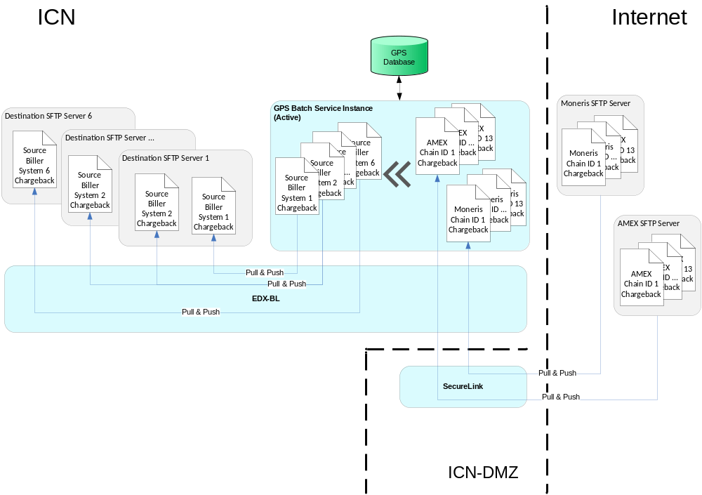

Chargeback Report Files Generation and Distribution Process Description
Chargeback report files:
- Originate from Moneris and American Express (Amex)
- Are generated by chain number, with a maximum of 13 chain number files
- Are generated daily, only for chain numbers having chargeback activities, meaning that not all 13 report files are produced every day

Process flow description:
- Amex generates daily a chargeback report file for each of the Bell chain number having chargeback cases and makes them available in a predetermined SFTP server folder
- Moneris generates daily a chargeback report file for each of the Bell chain number having chargeback cases and makes them available in a predetermined SFTP server folder
- Once a day, at a pre-determined time, EDX-BL pulls all the chargeback report files present from both Moneris and Amex SFTP servers through the ICN-DMZ SecureLink gateway
- EDX-BL pushes the chargeback report files to the active GPS batch server SFTP folder
- Once all the chargeback report files are received, GPS:
  - Transforms and enriches the files and produces one output file per biller system (up to 6 output files)
  - Synchronously reads and writes transaction related data to the GPS database required to enrich the files
  - Asynchronously writes internal processing information to the GPS database log tables
  - After all files transformation and enrichment is completed, makes the output chargeback report files available in its SFTP folder
- EDX-BL inspects the presence of chargeback report files in the GPS batch server SFTP folder on a regular basis and pulls the file
- EDX-BL pushes the file to the predetermined destination SFTP servers located on the ICN :
Note:
- Up to 6 destination SFTP servers
- A single chargeback report file may be pushed to more than one destination SFTP server

NOTE:
Although not represented on the diagram, potential error conditions on chargeback report files are managed as follows:
- GPS excludes the processing of any Moneris or Amex chargeback file in error and makes a log entry to trigger a Compuware Server Vantage email alert to the GPS production support team

Daily Report Files Distribution Process Diagram
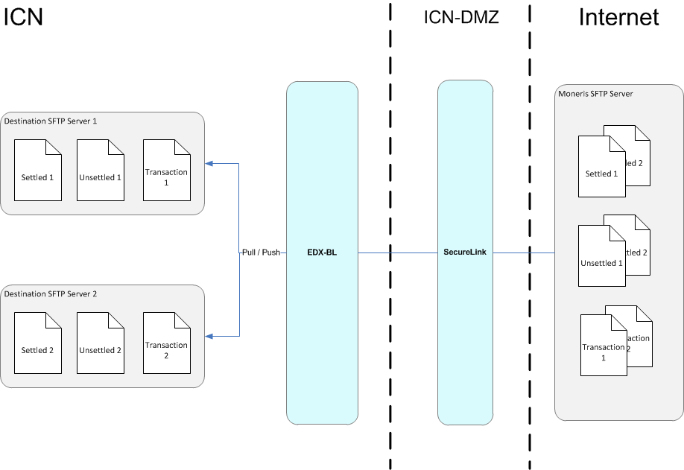

Daily Report Files Distribution Process Description
Daily report files:
- Originate from Moneris
- Consist of the following:
  - Settled report file
  - Unsettled report file
  - Daily transactions report file
- Are generated daily for each BSS, with a maximum of 6 (2 X 3) BSS files:
  - Virgin Prepaid
  - Fund$In

Process flow description:
- Moneris generates each of the daily report files for each BSS and makes them available in a predetermined SFTP server folder
- EDX-BL inspects the presence of a daily report file on a regular basis and pulls the file through the ICN-DMZ SecureLink gateway
- EDX-BL pushes the file to the predetermined destination SFTP servers located on the ICN

Development View Model
This section describes the various components of the Generic Payment Service (GPS) Architecture. The targeted audience is GPS architects, developers and maintenance/ Support team members interested in a lower detail level of the key GPS application components. The System Design Specification document provides more details about the Design of the different GPS components.

Components Model Diagram
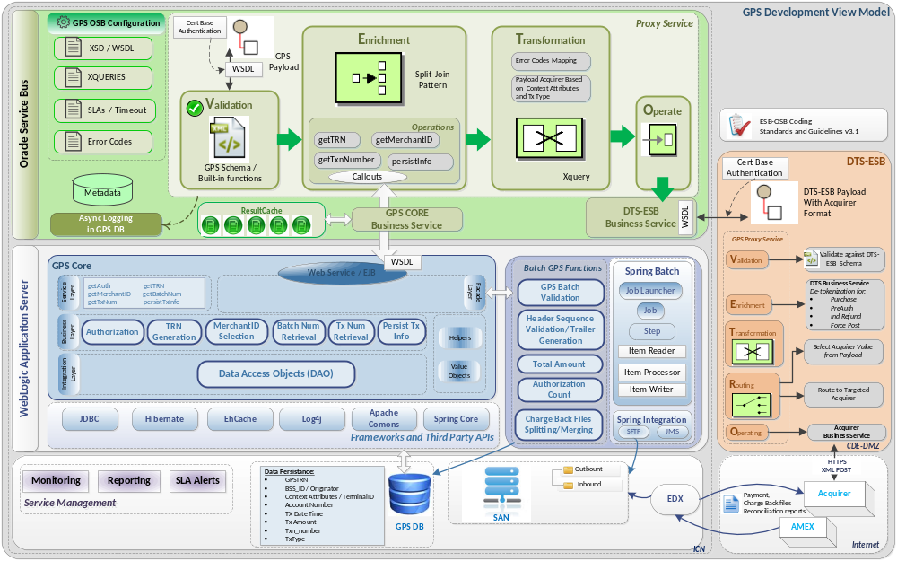

Components Model Description

GPS Services
There are 2 services that GPS exposes to Bell Business Support Systems (BSS) requiring Credit Card payment transactions with one or more payment processors: GPS Online Service and GPS Batch Service.

GPS Online Service
The GPS Online Service is a standard-based Web Service exposing a generic Credit Card Payment Service to BSSs requiring synchronous credit card transactions. The GPS Web Service is conformed to the best practices and OSB Guidelines and coding Standard highlighted by B-Side Technical Team in the ESB-OSB_Coding_Standards_and_Guidelines_V3.1.
The GPS Web Service is defined by:
- A Service Contract Documentation (Interface Design Document)
- A WSDL describing how the GPS online service is to be called
- XML Schema defining the Data elements required and the response elements returned.
- 2 way SSL Certificate Authentication Mechanism

GPS Batch Service
The GPS Batch Service is invoked through Batch File Process. Its main function is to process Chargeback and Credit Card file payments requests and responses through a generic Batch interface defining:
- The transformation rules for each field
- The File layout
- The File format: Fixed Length (FL) or Comma Separated Value (CSV)

GPS Components
The diagram in section 2.3.1 provides an overview of the GPS components and Application tiers in a Bell ESB Architecture. The GPS components are grouped into 4 main Modules deployed in WebLogic Application Server or Oracle Service Bus.

GPS Core
The GPS core is a main module that contains the business functionalities that are requested by both the Online Flow and the Batch Flow. It’s a common component that is deployed in the Online and Batch servers at the WebLogic Application Server level.
The following sections describe the GPS Core functions and the GPS Core Architecture Model.

Logical Layers
GPS architecture is based on the best practices over the Industry of Software development and client/Server applications. The layers shown in the diagram of the GPS core is a common design in the J2EE applications. The modules hosted on each layer are managed by the Spring Framework to wire and orchestrate the interaction between them.
Here’s summary of each layer:
Layer | Description
Façade Layer | The Facade Layer is used as a Gateway to access the GPS Core Service Layer. It exposes the common services required to fulfill the needs for Bell Systems processing Credit Card Payment with the acquirers via specific EJB / Web Service operations for Online Transactions or local methods for the Batch Transactions.
Service Layer | The Service Layer hosts generic interfaces by abstracting completely the implementation code of the Business Core functions.
Business Layer | The Business Layer contains the implementation of the GPS functions.
Integration Layer | The Integration Layer contains Data Access Objects (DAO) responsible for receiving requests from the Business Object to perform low level operation(s). The Adapter is responsible for wrapping the logic and the implementation of the connectivity to the GPS Database.
Common Objects | The helper classes are called for any utility required by a specific Business function. The Value Objects encapsulate the Business Data in order to be retrieved from the different layers.

Frameworks and Third Party Libraries
GPS components leverage the well-known proved third party frameworks and APIs widely used in Bell Applications. Here’s a brief description for each one of them.

Logical Tier | Description
Spring | Spring is a light framework in charge of creating GPS objects via Injection mechanism; It facilitates the wiring and orchestration between the classes in the different layers.
JDBC | JDBC stands for Java Database Connectivity. It is an API allowing communication with Databases
Hibernate | Hibernate is a framework implementing Object-Relational mapping between Java objects and database tables. This framework is used in GPS application to load configuration from the database. Spring and Hibernate can be easily integrated together by using Spring support API.
EHCache | EHCache is an open source library, standards-based cache used to boost performance, offload the database and simplify scalability.
Log4j | Log4j is the standard library for Application logging. Log Files Layout are easily configurable as well as the level of logs required (debug, info, error, warning,…)
Apache Commons | Apache Commons is a set of libraries useful to facilitate specific processing without custom coding. The following are example of libraries that are used in GPS:  - DBUtils: JDBC Helper Library.  - IO: Collection of I/O utilities  - Math: Lightweight, self-contained mathematics components.  Note that during the design phase, the list may be updated.

GPS Core Business Functions
The following highlights the core business functions for GPS that are used for online and batch.
Functionality | Description
Authorization | Used to validate if a BSS is authorized to communicate with GPS
TRN Generation | The Transaction Reference Number (TRN) Generation is a function that is called for each Online or batch Transaction requiring it (e.g. Purchase, PreAuth)
Merchant ID Selection | This function is to retrieve the Merchant ID based on the TerminalID / Contexct attributes
Batch Number Retrieval | This function is to determine the Batch Number from the Reference Number returned from the acquirer. Note that in the scope of this phase it’s used only for the Online.
Tx Number Retrieval | This function is to retrieve the Tx Number for specific transactions such as Completion and Refund in order to be submitted to the acquirer
Persist Tx Info | This function goal is to persist the relevant information required for charge back generation, follow up transactions enrichment and reconciliation investigation.

GPS Batch
The GPS Batch is a J2EE Application deployed in WebLogic Application Server and it is responsible for processing bulk credit card transactions received from the BSSs through EDX. These batch files located in a SAN, are accessed either locally or remotely via SFTP on regular intervals and queued for processing:
- Determine the BSS ID
- Determine if the file CSV or FL format
- Perform validation
- Perform the right transformation according to the targeted acquirer

For each file received, GPS Batch processes record by record and perform specific actions:
- Determine the acquirer based on context attributes or Terminal ID
- Determine the merchant ID based on context attributes or Terminal ID
- Validate the right Sequence Number
- Generate a TRN on each transaction record

For each response file, GPS performs the following operations:
- Calculate the total amount by merchantID
- Calculate the authorization count by MerchantID

Other functionalities are performed for the charge back files. They are retrieved from Moneris and Amex and processed by splitting the files and merging the files according to certain criteria. More details regarding the charge back files are described in the System Design Specifications.

In addition to the GPS core, the Batch server hosts the GPS Batch Libraries (deployed into the Batch servers only).

GPS Batch Third Party Frameworks
GPS Batch Application leverages the frameworks Spring Batch and Spring Integration.

Spring Batch
Spring Batch abstracts the concepts of Batch Jobs and Steps. In the case of GPS it helps define the steps that need to be performed either at the file level: Naming Convention, decryption… or at the transaction level such as validation, extract fields’ value… It offers built-in mechanism such as readers, parsers, and writers and also to handle the errors that may occur during the treatment.

Spring Integration:
Spring Integration is an efficient framework to handle the operations of pulling the files on regular intervals, queue and control the parallel processing,. In fact, it makes all the operations surrounding the main business logic easy to configure by offering built in connectors and functions.
Finally, being part of the same framework, Spring Batch and Spring Integration offer excellent integration with one another.

GPS Batch Functions
The GPS Batch business functions are:
Functionality | Description
GPS Batch Validation | This module validates the file structure.
Sequence Number Validation | This functionality validates the sequence number of the batch file per BSS.
Trailer / Header Generation | This function generates header / trailer for the Charge Back Files and the response
Total Amount | This function calculates the total amount of the transactions processed successfully by MerchantID on Moneris end.
Authorization Count | This function calculates the total of transactions processed by MerchantID on Moneris end
Charge Back Files Splitting and merging | This module generates charge back files by splitting the charge back files retrieved from Moneris and Amex by Source Biller

GPS Online
GPS Online Application is deployed in multiple instances load balanced across both regions (QC and ON). It is deployed in Oracle Service Bus acting as an intermediary between Bell Payment Applications and the Credit Card Payment Processors. GPS Online is exposed via a standard Web Service to BSSs to perform Credit Card Transactions. The WSDL highlights all the rules about the how to communicate with GPS and what Data to send and expect through its schema.
The communication between BSSs Application and GPS online is secure by using a two-way SSL certificate authentication mechanism. The configuration of the certificate is set in OSB Key store in order to intercept each request. Each BSS that needs to communicate with GPS is configured in the GPS Database.

GPS Online is designed by applying the VETRO principles Design Pattern: Validation, Enrichment, Transformation, Routing and Operating. A Proxy Service is created and configured to orchestrate all these actions:
Validation :
Each transaction is validated according to the schema definition and additional rules related to the transaction type. The validation is performed by using OSB built-in functions or custom formulas for specific treatment.
Enrichment :
Transactions are enriched to fulfill the needs either for the BSSs, GPS or downstream Systems (DTS-ESB, Acquirers,…). Specific parallel invocations to the GPS Core Business Service are performed through callouts by applying the Split Join Design Pattern in order to boost performance:
- getTRN
- getMerchantID
- persistInfo
- getTxnNumber (Applied on Void, Refund and Completion Transactions)
Moreover, any information that is reused is cached locally in each instance.
Timeouts are set for each backend call as well as the maximum concurrent inbound threads. This last one will be determined during the performance tests.
Transformation :
Based on the Acquirer determined during enrichment, the payload request is transformed according to the Acquirer schema by using the OSB Built-in functions and XQuery scripts.
Response codes returned from all different levels (GPS Core, DTS-ESB, Acquirer …) are mapped and transformed to a defined set of Bell internal codes.
Operating :
Finally, the Operating Step consists of calling the DTS-ESB Business Service for DE-tokenize and forward to the appropriate acquirer.

Monitoring and Reporting
Every critical application needs to be monitored and GPS is not an exception. OSB allows monitoring system operational health and flags problems in messaging services when they occur. GPS will establish service level agreements (SLAs) and configure rules that trigger alerts to the Support groups.
In addition, OSB provides the capability to review statistics. Therefore, GPS is built in a way that transactions are logged asynchronously at an operation level for more granular analysis.

DTS-ESB
A new service GPS Service is added to existing DTS-ESB platform in order to DE-tokenize and forward the requests to the target acquirer.
This service also exposes to GPS with two-way SSL Certificate Authentication mechanism.
The functions in DTS-ESB extract the Acquirer ID and Transaction Type from the request in order to extract the token (if any) and forward the payload to the right Business Service Acquirer.
The response from the acquirer will be returned as is without any manipulation.

Physical View Model
The following sections give an overview of the server distribution model for the GPS production environment. The infrastructure is based on both physical and virtual server components.
For a more comprehensive description of all GPS environments (e.g. Production, Production Support, User Acceptance Test), refer to the GPS Environment Specification document.

Production Environment Diagram
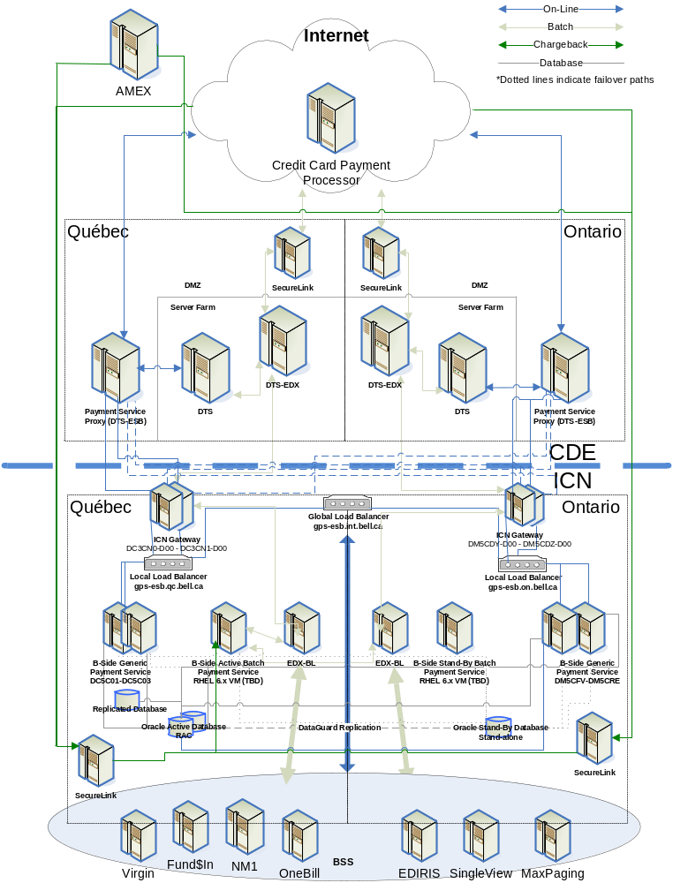

Production Server Components
Server Identification | Services | Description
B-Side Online Generic Payment Service | Oracle Service Bus over WebLogic Service Bus  - Online credit card transaction request processing  - Online credit card transaction logging  Regional cluster with HA across nodes and servers  Ontario Cluster is also the active fail over / DRP for its Quebec counterpart services (and vice-versa) | GPS on-line functions include  - Validation  - Enrichment  - Transformation  - Operating (forward transaction to DTS-ESB)  - Upon return (or timeout) from DTS-ESB, respond to originator
B-Side Batch Generic Payment Service | WebLogic Application Server (using Spring Batch / Spring Integration)  - Batch credit card transaction request processing  - Internal processing information logging | GPS batch functions include  - GPS Batch Validation  - Payment request files transformation and enrichment  - Charge Back Files transformation and enrichment
GPS Database | - Oracle 11g with Real Application Cluster  - Data Guard used to replicate data from the primary database in Quebec to the Ontario Standby server  - Materialized Views used to replicate data from the primary database to a dedicated reporting database | Used for:  - GPS Parameters Data Store  - GPS Transaction Data Store
GPS Replicated Database | - Oracle 11g  - Materialized Views replicated from the primary database | Used for:  - GPS Transaction Data Store (Replicated)
ICN Gateway | Linux  - ICN request routing to CDE-DMZ servers | Acts as a network layer 3 router to route ICN incoming requests to CDE-DMZ facing servers based on port numbers. The data is passed as is with no SSL termination and no decryption of payload to the Internet Online Gateway.  Also support routing from CDE-DMZ servers to ICN servers. The service is accessed via a Virtual IP across both regions in a round-robin method.
Payment Service Proxy (DTS-ESB) | Oracle Service Bus over WebLogic Service Bus (new DTS-ESB service)  - Online detokenization and forwarding of the request to the right credit card payment processor | - For any request containing a token, invokes the DTS synchronous Web service interface to get the corresponding PAN  - After PAN substitution, invokes the Moneris synchronous HTTPS XML interface.  - On reply from Moneris, or after a timeout delay is reached, DTS-ESB returns the response message to GPS
DTS | WebSphere  - DTS application  - RSA Application  - RKM Client  - Oracle Clients to RSA and DTS Oracle DBs  Regional cluster with HA across WAS nodes and servers  Ontario Cluster is also the active fail over / DRP for its Quebec counterpart services | DTS application functions used specifically for the GPS implementation are the following:  - Authentication  - Authorization  - RSA calls for de-tokenize  All components communicate with its own internal components
DTS-EDX | GSX Bizlink application  This service is also in Ontario but only used for DRP purposes and is NOT active | Batch payment request file transfer :  - From GPS to DTS  - From DTS to Moneris
EDX SecureLink (ICN) | GSX SecureLink  - Reverse-proxy  - Proxy  This service is also in Ontario but only used for DRP purposes and is NOT active | All file transfers from Moneris and Amex are channelled by these services
EDX-SFTP | Secure file transfer | File exchange between EDX-BL (ICN) and DTS-EDX must go through the dedicated EDX-SFTP server hosted on the ICN DTS Gateway in order to maintain PCI-DSS compliancy
EDX-BL (ICN) | As current | Acts as a gateway for all file transfers to and from the ICN BSS applications with its EDX component in CDE
EDX SecureLink (CDE) | GSX SecureLink  - Reverse-proxy  - Proxy  This service is also in Ontario but only used for DRP purposes and is NOT active | All file transfers related to batch processing to Moneris will be channelled by these service

Glossary
Term | Definition
API | Application Programming Interface
BSS | Business Support System
CDE | Cardholder Data Environment
CDE DMZ | Cardholder Data Environnent De-Militarized Zone
CSV | Comma Separated Value
DAO | Data Access Object
DTS | Data Tokenization System
EDX | Electronic Data Exchange
EJB | Enterprise JavaBean
ESB | Enterprise Service Bus
FL | Fixed Length
GPS | Generic Payment Service
HTTPS | HyperText Transfer Protocol Secure
ICN | Internal Communication Network
J2EE | Java 2 platform Enterprise Edition
PAN | Primary Account Number
PCI DSS | Payment Card Industry Data Security Standard
SAN | Storage Area Network
SFTP | Secure File Transfer Protocol
SOAP | Simple Object Access Protocol
SSH | Secure SHell
SSL | Secure Sockets Layer
TRN | Transaction Reference Number
WSDL | Web Service Definition Language
XML | Extensible Markup Language

